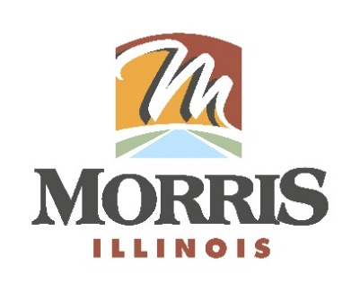
CITY OF MORRIS
700 N. Division Street
Morris, IL 60450
Phone (815) 942-1855
Fax (815) 942-0216
Bill Martin
Building & Zoning Officer
bmartin@morrisil.org
www.morrisil.org

MORRIS PLANNING COMMISSION
AGENDA

TO: JOHN WILKINSON, JIM JENNINGS, BARRY NARVICK, R.H. COLEMAN,
DENNIS HACKETT, JEFF WACHOWSKI, TOM TALARICO, ALDERMAN JULIAN HOUSTON, CITY ATTORNEY GARRETT WHEELER,
CITY PLANNER MIKE HOFFMAN

FROM: BILL MARTIN

DATE: March 16th, 2026

RE: PLANNING COMMISSION MEETING

There will be a meeting of the Morris Planning Commission on March 25TH, 2026, at 5:30 p.m. The meeting will be held in the City Council Chambers (ROOM 1107) at the Morris Municipal Services Building, 700 North Division St. in Morris, Illinois.

AGENDA
- Call the meeting to order.
- Attendance will be taken.
- The minutes from November 19th, 2025, meeting will be reviewed and voted on.
- Public Hearing to consider an application filed by Brew Horizons LLC 2000 West Park Drive, suite 130 Westborough MA 01581 and Millco Morris LLC 5215 old orchard road suite 130 Skokie IL 60077 for a conditional permitted use to have a drive-thru pursuant to section 48-1068 (25) of the Morris Municipal code at 2413 Sycamore Drive.
- Planning Commission Recommendation
- Consider an application for minor subdivision at 308 Liberty Street (parcel # 05-04-485-010).
- Planning Commission Recommendation
- Audience Participation.
- Close the meeting.

