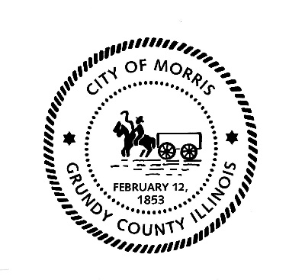
CITY OF MORRIS

700 N. Division Street
Morris, IL 60450
Phone (815) 942-1855
Fax (815) 942-0216
Bill Martin
Building & Zoning Officer
bmartin@morrisil.org
www.morrisil.org

MORRIS PLANNING COMMISSION
AGENDA

TO: JOHN WILKINSON, JIM JENNINGS, BARRY NARVICK, R.H. COLEMAN,
DENNIS HACKETT, JEFF WACHOWSKI, TOM TALARICO, ALDERMAN DEAN TAMBLING, CITY ATTORNEY GARRETT WHEELER,
CITY PLANNER MIKE HOFFMAN

FROM: BILL MARTIN

DATE: OCTOBER 22ND, 2024

RE: PLANNING COMMISSION MEETING

There will be a meeting of the Morris Planning Commission on OCTOBER 30TH, 2024, at 5:30 p.m. The meeting will be held in the City Council Chambers (ROOM 1107) at the Morris Municipal Services Building, 700 North Division St. in Morris, Illinois.

AGENDA
- Call the meeting to order.
- Attendance will be taken.
- The minutes from the SEPTEMBER 25TH, 2024, meeting will be reviewed and voted on.
- CP MORRIS LAND EAST, LLC. AND DRI/CHI BRISBIN ROAD, LLC. REQUEST PRELIMINARY PLAT APPROVAL FOR CLARIUS PARK MORRIS EAST - GBOGH.
- PLANNING COMMISSION RECOMMENDATION.
- CP MORRIS LAND EAST, LLC. AND DRI/CHI BRISBIN ROAD, LLC. REQUEST FINAL PLAT APPROVAL FOR CLARIUS PARK MORRIS EAST - GBOGH.
- PLANNING COMMISSION RECOMMENDATION.
- Audience Participation.
- Close the meeting.

