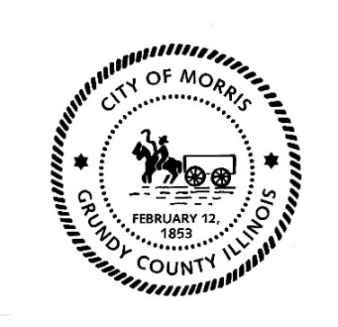
CITY OF MORRIS

700 N. Division Street
Morris, IL 60450
Phone (815) 942-1855
Fax (815) 942-0216
Bill Martin
Building & Zoning Officer
bmartin@morrisil.org
www.morrisil.org
ZONING BOARD OF APPEALS
AGENDA

TO: TOM DZURYAK, BOB TESDAL, LYLE HECHT, TIM ROBOWSKI,
BILL KLOTT, BILL BUTTON SR., JUSTIN OLSON, JULIAN HOUSTON AND ATTORNEY GARRETT WHEELER

FROM: BILL MARTIN
DATE: SEPTEMBER 17TH, 2024
RE: MORRIS ZONING BOARD OF APPEALS
THERE WILL BE A MEETING OF THE MORRIS ZONING BOARD OF APPEALS ON WEDNESDAY SEPTEMBER 25TH, 2024 AT 4:30 P.M. THE MEETING WILL BE HELD IN THE CITY COUNCIL CHAMBERS (Room 1107) OF THE MORRIS MUNICIPAL SERVICES BUILDING. PLEASE ADVISE ME IF YOU ARE UNABLE TO ATTEND.

AGENDA
CALL THE MEETING TO ORDER.
ATTENDANCE IS TAKEN.
CHAIRMAN REQUESTS A MOTION ON THE MINUTES FROM THE WEDNESDAY JUNE 26th, 2024, ZONING BOARD OF APPEALS MEETING.
- OPEN PUBLIC HEARING TO CONSIDER AN APPLICATION FOR A ZONING VARIANCE/VARIATION TO SECTION 48-1962 (1) FOR THE REQUIRED EXTERIOR FAÇADE MATERIALS FILED BY EAST STREET MORRIS LLC 1353 EAST STREET MORRIS ILLINOIS 60450 AND DOMINICK PERONA 1911 CINNAMON COURT JOLIET ILLINOIS 60435.
- MOTION TO CLOSE PUBLIC HEARING.
- ZONING BOARD OF APPEALS RECOMMENDATIONS.
OTHER BUSINESS.
AUDIENCE PARTICIPATION.
MOTION TO CLOSE THE MEETING.

