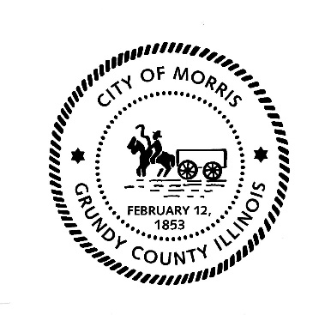
CITY OF MORRIS

700 N. Division Street
Morris, IL 60450
Phone (815) 942-1855
Fax (815) 942-0216
Bill Martin
Building & Zoning Officer
bmartin@morrisil.org
www.morrisil.org

MORRIS PLANNING COMMISSION
AGENDA

TO: JOHN WILKINSON, JIM JENNINGS, BARRY NARVICK, R.H. COLEMAN,
DENNIS HACKETT, JEFF WACHOWSKI, TOM TALARICO, ALDERMAN DEAN TAMBLING, CITY ATTORNEY GARRETT WHEELER,
CITY PLANNER MIKE HOFFMAN

FROM: BILL MARTIN

DATE: MAY 22nd, 2024

RE: PLANNING COMMISSION MEETING

There will be a meeting of the Morris Planning Commission on Wednesday, May 29TH, 2024, at 5:30 p.m. The meeting will be held in the City Council Chambers (ROOM 1107) at the Morris Municipal Services Building, 700 North Division St. in Morris, Illinois.

AGENDA
- Call the meeting to order.
- Attendance will be taken.
- The minutes from the February 28th, 2024, meeting will be reviewed and voted on.
- OPEN PUBLIC HEARING TO CONSIDER AN APPLICATION FILED BY CARA WIECHEN AND JENIFER ZDANWIC FOR A CONDITIONAL PERMITTED USE TO OPERATE A MICROBLADING ESTABLISHMENT AT 1360 N. DIVISION STREET.
- CLOSE PUBLIC HEARING.
- PLANNING COMMISSION RECOMMENDATION.
- OPEN A PUBLIC HEARING TO CONSIDER AN APPLICATION FILED BY THE CITY OF MORRIS FOR A ZONING TEXT AMENDMENT TO UPDATE CHAPTER 48 OF THE MORRIS MUNICIPAL CODE SPECIFICALLY OFF-STREET PARKING, CARGO CONTAINERS, PERMITTED USES IN M1 MANUFACTURING DISTRICTS AND SIGN PROVISIONS.
- CLOSE PUBLIC HEARING.
- PLANNING COMMISSION RECOMMENDATION.
- BRANDON ROAD PROPERTIES LLC REQUEST PRELIMINARY PLAT APPROVAL FOR GRAND OAKS SUBDIVISION UNITS 2 THROUGH 7.
- PLANNING COMMISSION RECOMMENDATION.
- BRANDON ROAD PROPERTIES LLC REQUEST FINAL PLAT APPROVAL FOR GRAND OAKS SUBDIVISION UNIT 2 THROUGH 7.
- PLANNING COMMISSION RECOMMENDATION.
- COMMISSION TO DISCUSS AMENDMENTS TO THE COMPREHENSIVE PLAN.
- Audience Participation.
- Close the meeting.

